Project Development Phase
Performance Testing & User Acceptance Testing
Date | 03 November 2026
Roll Number | 323103282099
Project Name | Incident Lifecycle Automation in ServiceNow
Maximum Marks | 4 Marks

What I Built
All the work was done on my ServiceNow Personal Developer Instance. I used one scenario the whole way through: incident INC0010005, "Unable to connect to Corporate VPN from home office", with child incident INC0010006 and emergency change CHG0030003.
- Service hierarchy: created the service Remote Access and the service offering Corporate VPN with Parent = Remote Access.
- Incident creation: impersonated Beth Anglin, opened Service Operations Workspace and created INC0010005 for caller Michael Hoefer, assigned to the Service Desk group.
- Classification: added the description, Channel = Phone, Category = Network, Subcategory = VPN, Urgency = 2 - Medium, Service = Remote Access, Service offering = Corporate VPN and CI = ThinkStation S20, with the work note "Classified and assigned incident." Then clicked Assign to me.
- Knowledge integration: opened Agent Assist, filtered to Knowledge Articles, marked KB0000008 (How to configure VPN for Apple Devices) as Helpful and attached it with the comment "Follow the Steps and Resolve the Incident."
- Collaboration: added Samantha Bordwell to the watch list and Beth Anglin to the work notes list, and moved the incident to the Network group.
- Level 2 tracking: impersonated David Loo, opened the incident and clicked Assign to me. Checked the description, attached knowledge and Task SLAs.
- Emergency change: changed the CI to PowerEdge T110 II, set State = On Hold with reason Awaiting Change, and linked emergency change CHG0030003.
- Child incident: created INC0010006 for caller Fred Luddy from Related records, Child Incidents, New.
- Resolution: added the probable cause and the resolution (Workaround provided, "Restarted VPN-SRV-02 service as per emergency change request.") and resolved. The child resolved along with the parent.
- Knowledge creation: used Create Knowledge, picked the IT knowledge base and the Standard article layout, and saved it. The new article KB0010003 appears under Created Knowledge.

Problems I Ran Into
Not everything went smoothly, and fixing these taught me quite a bit about how the platform behaves.
Issue | Why it happened | How I fixed it
My knowledge article stayed in Review | The IT knowledge base used the Approval Publish flow, so the approval went to its owner | Approved the request from the article's Approvals tab
Corporate VPN did not appear in Service offering | I had saved the service as "Remote Acess" (spelling mistake) | Corrected the name to Remote Access and re-linked the offering
No "Create Emergency Change" option on the incident | That action was not available on this instance's incident form | Created the change from the Change Requests list and linked the incident from the change side
No Change Request field on the incident form | The field was not on the form layout | Added the Incidents related list to the change form and linked INC0010005 there
Agent Assist showed only catalog items | The search filter was set to Knowledge & Catalog | Switched the filter to Knowledge Articles
Articles hidden while impersonating | Knowledge user criteria limit what non-admin users can read | Ran the knowledge checks as admin and confirmed agent access separately

Performance Testing
For this project I judged performance by how well the lifecycle actually held up: did the tests pass, did the SLAs behave the way they should, and did the records stay consistent with each other.
S.No. | Parameter | Values | Screenshot
1 | Project Summary | Incident lifecycle automation in ServiceNow: classification, Agent Assist knowledge, escalation to Network Level 2, emergency change, child incidents, resolution, knowledge creation and SLA tracking | Screenshot 1
2 | Accuracy (functional) | 7 out of 7 validation test cases passed (100%) | Screenshot 2
3 | SLA Performance | Priority 4 response SLA (8 hours): completed but breached at 112.5%, because the incident waited before it was picked up. Priority 4 resolution SLA (2 days): paused at 18.75%, not breached. Network group resolution SLA: paused, not breached | Screenshot 3
4 | Data Integrity | Child incident INC0010006 resolved automatically with parent INC0010005, and every field change is recorded in Activity | Screenshot 4

Screenshots
Screenshot 1: Incident created and classified
INC0010005 after Beth Anglin logged and classified it in Service Operations Workspace.
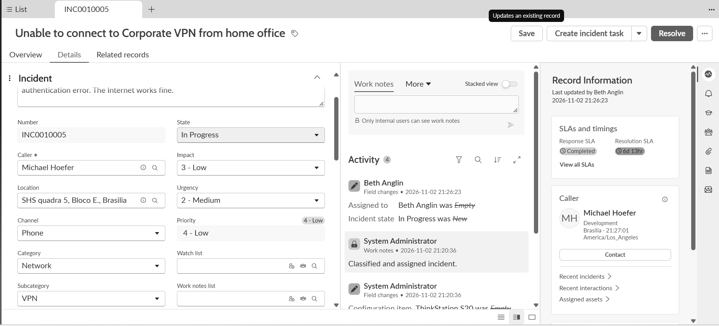
INC0010005 classified as Network / VPN
Screenshot 2: Incident resolved
The same incident at the end, resolved, with the watch list and work notes list still in place.
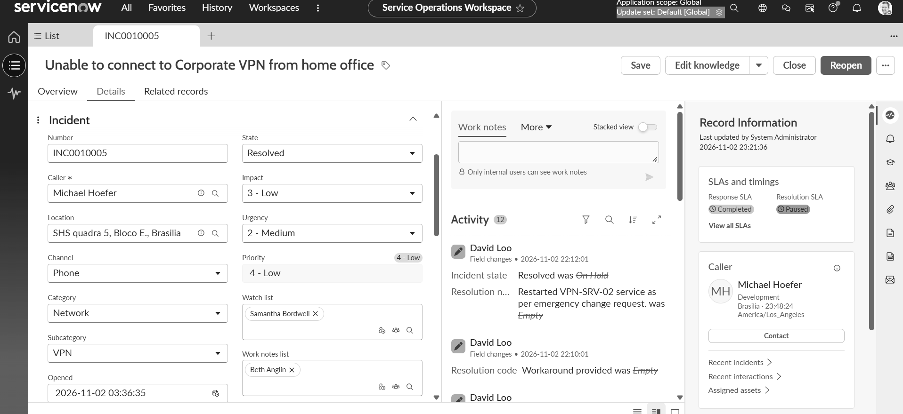
INC0010005 in Resolved state
Screenshot 3: SLA tracking
Task SLAs for the incident. The response SLAs are complete and the resolution SLAs are paused.
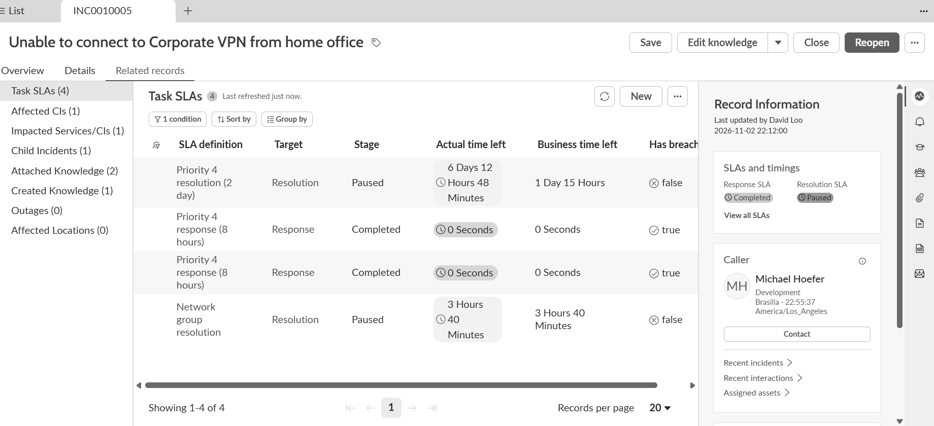
Task SLAs on INC0010005
Screenshot 4: Child incident
INC0010006 sitting under the parent incident in Related records.
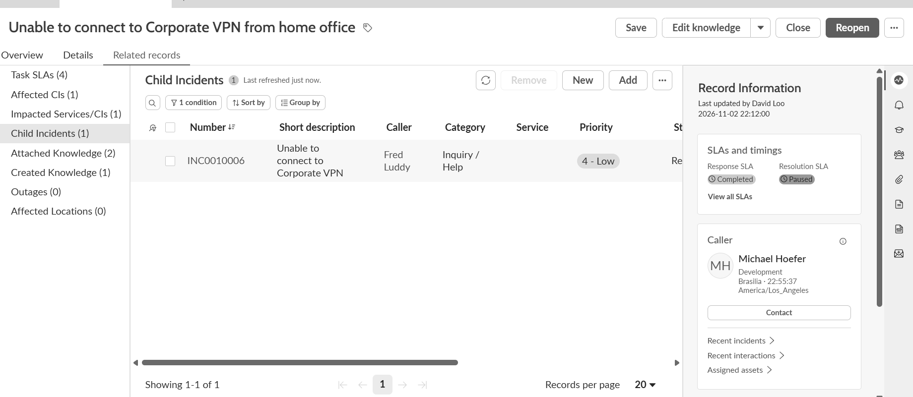
Child incident INC0010006

User Acceptance Testing (UAT)

1. Purpose
Before calling the build finished, I went back over everything as if I were the end user. Here I note what I tested, what broke along the way and whether anything is still open.

2. Defect Analysis
I hit six issues while building. Below I have sorted them by how serious they were and how each one ended up being handled.
Resolution | Severity 1 | Severity 2 | Severity 3 | Severity 4 | Subtotal
By Design | 0 | 1 | 1 | 0 | 2
Duplicate | 0 | 0 | 0 | 0 | 0
External | 0 | 0 | 0 | 0 | 0
Fixed | 0 | 2 | 2 | 0 | 4
Not Reproduced | 0 | 0 | 0 | 0 | 0
Skipped | 0 | 0 | 0 | 0 | 0
Won't Fix | 0 | 0 | 0 | 0 | 0
Totals | 0 | 3 | 3 | 0 | 6

"By Design" covers the missing emergency change action and the knowledge user criteria. Both are how this instance is set up rather than mistakes in my build.

3. Test Case Analysis
I ran seven test cases in total. All of them passed, and none were skipped.
Section | Total Cases | Not Tested | Fail | Pass
Incident Lifecycle and Escalation | 2 | 0 | 0 | 2
Change Integration | 1 | 0 | 0 | 1
Knowledge Creation | 1 | 0 | 0 | 1
Child Incident Management | 1 | 0 | 0 | 1
SLA Tracking | 1 | 0 | 0 | 1
Multi-team Collaboration | 1 | 0 | 0 | 1

Test case details
Test ID | Scenario | Expected Result | Actual Result | Status
TC-01 | Incident lifecycle end to end | INC0010005 moves New, In Progress, On Hold, Resolved | Activity shows each state change; State = Resolved | Pass
TC-02 | Escalation process | Incident moves from Service Desk to Network and is assigned to David Loo | Assignment group = Network, Assigned to = David Loo | Pass
TC-03 | Change integration | Emergency change linked to the incident | CHG0030003 Incidents tab lists INC0010005 | Pass
TC-04 | Knowledge creation | Article created from the resolved incident | Created Knowledge (1): KB0010003; Attached Knowledge (2) | Pass
TC-05 | Child incident management | Child resolves with the parent | INC0010006 State = Resolved | Pass
TC-06 | SLA tracking | SLAs visible with stage and breach status | Task SLAs (4): Completed and Paused | Pass
TC-07 | Multi-team collaboration | Watchers and work notes followers saved | Watch list = Samantha Bordwell, Work notes list = Beth Anglin | Pass

Role check: I also opened INC0010005 as Beth Anglin (Service Desk), David Loo (Network Level 2) and the System Administrator. Each of them could see the record and the actions their role allows.

